MEET THE MONKS
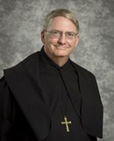
Abbot Gregory Mohrman is the third abbot of the monastery, and the first alumnus of the Priory school to serve as Headmaster and then as Abbot.

TRIVIA: Abbot Gregory enjoys playing the piano, and has the same piano teacher today that he has had since he was in the 5th grade.

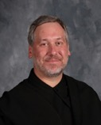
Prior Cassian Koenemann is an alumnus of our school. He graduated from Vanderbilt with a degree in economics, and was working for IBM in Washington DC when he started to hear the call to be a monk of Saint Louis Abbey.

TRIVIA: Father Cassian captain of the football team at Priory (and the first rugby player I ever sent to the hospital)!
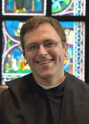

Father Cuthbert Eliiot is a graduate of Holy Cross College, a veteran actor, mock trial coach, and the headmaster of the school.

TRIVIA: Father Cuthbert made the highest grade possible (a “first”) at Oxford when he studied Theology there!

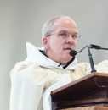
Father Aidan grew up on “The Hill” in South Saint Louis. He did his theological studies at Mundelein and serves as pastor of our parish.

TRIVIA: Everyone likes Father Aidan. There are no exceptions to this.

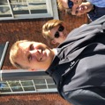
Father Augustine is the author of three books and our Director of Vocations. He has degrees from Rice University, Oxford University, and Middlebury College.

TRVIA: Father Augustine was a surfer and a professional juggler!

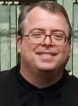
Father Andrew is a polymath autodidact. You won’t know what that is, but he will. A graduate of Saint Louis University, he reads everything and anythig he can get his hands on.

TRIVIA: Father Andrew is the infermarian, caring for the needs of the oldest in the monastery.

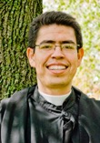
Father Athanasius Soto studied economics at UCLA. He was working as a government auditor when he discovered his call to be a monk.

TRIVIA: Father Athanasius used to weigh 300 pounds! Now he does hand-stand push-ups!

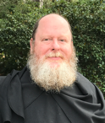
Father Francis is the abbey kitchenmaster and works part-time in the parish.

TRIVIA: Father Francis has three tattoos and speaks fluent Japanese!

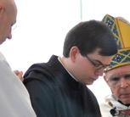
Brother Hugh made his solemn profession last January and works as the librarian in our school. He is a convert to Catholicism, an avid linguist, and a book-binder. He is currently studying Theology in Bavaria.

TIVIA: Before becoming a monk, Brother Hugh taught himself Korean--then moved to Korea for a year!
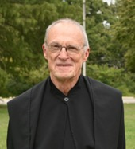
Father Lawrence is a scripture scholar. For many years, he taught English in our school, then Hebrew and Old Testament at Kenrick Seminary. He is the second American vocation to persevere at the abbey and the author of Praying the Psalms in Christ (Notre Dame Press)’

TRIVIA: in addition to his expertise in Hebrew, Father Lawrence is also adept at Latin and Greek, and speaks fluent French and German!

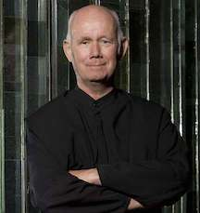
Father Gerard entered Saint Louis Abbey in 1980 with no thoughts of becoming a priest. Nonetheless, he hsa served as a teacher, pastor of our parish, and prior of the monastery.

TRIVIA: Father Gerard was friends with Dorothy Day!

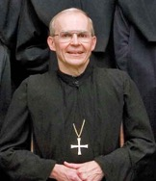
Abbot Thomas was the first American abbot of Saint Louis Abbey. After graduating from Harvard, he went to Oxford and was converted to Catholicism by Elizbeth Anscomb. He then taught Philosophy at Notre Dame before becoming a monk.

TRIVIA: Abbot Thomas was the world’s first disabled Rhodes Scholar!

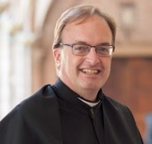
Father Dominic is a Theology teacher in our school, and the Director of Formation for the Abbey, and a published author.

TRIVIA: He is the first man to be ordained a priest and the first man to profess religious vows from his home parish in Troy Missouri!

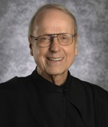
Father Benedict was the first American vocation to persevere at the abbey. He still works in the parish and school.

TRIVIA: Father Benedict recently learned Spanish so he could travel to
Chile, where he works with the Manquehue Apostolic Movement.

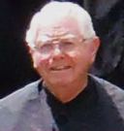
Born in Dublin, Father Finbarr is Irish in every imaginable way. He served as one of our first headmasters, and as a teacher of Math, French, and Theology. A natural contrarian, you can expect that anything you say to him will be contradicted in the most charming and baffling way.

TRIVIA: Father Finbarr captained the top high school rugby team in Ireland!

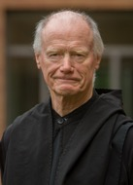
Father Ralph was born in England in 1938 and spent two years in the British Army with the elite “Sherwood Foresters” before becoming a monk at Ampleforth Abbey. After graduating from Oxford, he spent four years studying theology at Fribourg in Switzerland. He has served in the school, the parish, and as novicemaster and director of vocations for the abbey.

TRIVIA: Father Ralph has published seven books of poetry—and once taught himself Italian using only a copy of Dante’s Divine Comedy and an
Italian/English Dictionary.
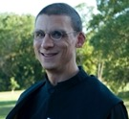
Father Linus is officially the smartest monk at the abbey. He earned his PhD in Physics from Princeton and teaches seven science classes in the school. In 2019, he won the University of Chicago Outstanding Educator Award. He is currently running our Tridentine parish in O’Fallon, Missouri.

TRIVIA: Father Linus is an avid rock-climber and cross-country runner!
Brother Symeon taught in the Fine Arts Department of our school for 25 years, followed by eight years as a monastic hermit.

TRIVIA: Under his tutelage, Priory students constructed two two-story stained glass windows for the high school, one of which is an accurate, scale reproduction of the Jesse Tree window from Chartre Cathedral!

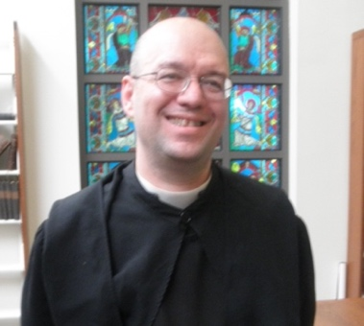
A liturgical expert and vocal advocate of the Extraordinary Form, before coming to the abbey, Father Ambrose put himself through Princeton while simultaneously running his family’s restaurant. He is currently serving as pastor of a parish at the South Pole (the Falkland Islands).

TRIVIA: Father Ambrose had a pet Puma growing up!

Brother Philip is extremely shy. (Thus, no photograph.) He is a choir oblate, meaning that he renews his vows yearly. He is our chief liturgist, and is responsible for all of our pamphlets, booklets, and liturgical aids.

TRIVIA: Brother Philip knows just about everything there is to know about Gregorian Chant. Go ahead! Test him!

